**Weekly report**

*Work on TFRecords and CASIA dataset*

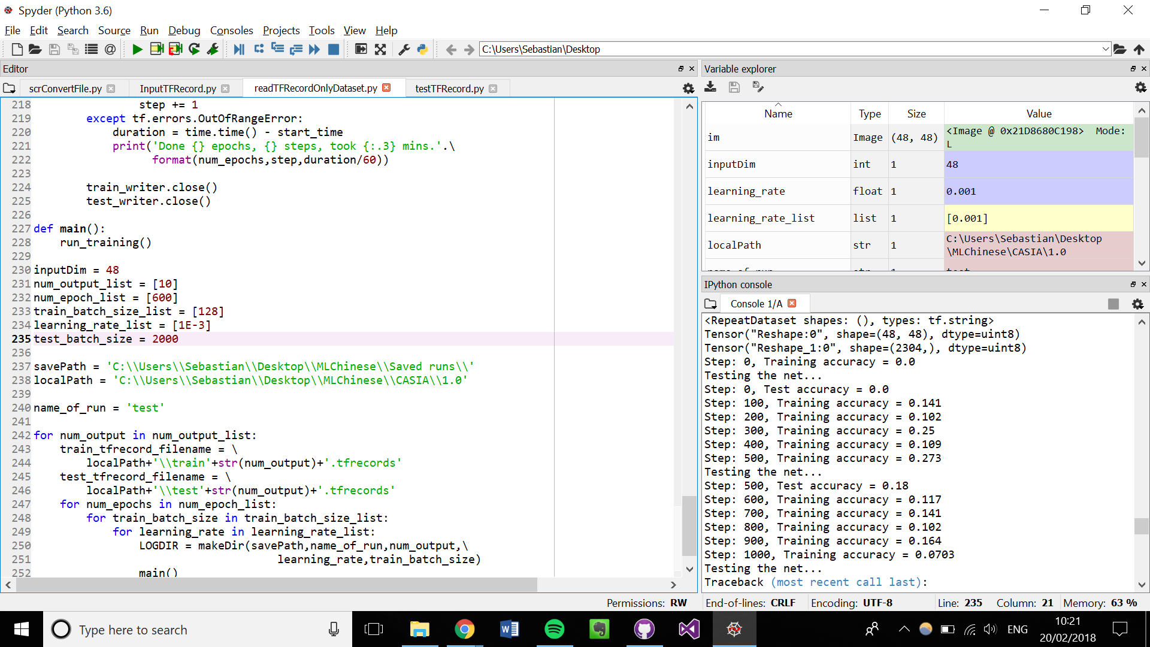

Figure : Training and testing accuracy jumping around all over the place

*Work on transfer learning*

I have continued to work on transfer learning. I have done more work on incorporating TFRecords into the transfer learning scripts however this is not yet complete. In addition, we have decided that when it comes to retraining the final layer, this will have to be done using .npz files as the bottlenecks cannot easily be saved as TFRecords format. However, as the bottlenecks do not need augmenting and as they are used to train only one layer, this is not significant.

**Action points for the next week**

1. Work on the bottleneck script so that it can save the bottlenecks as a dataset.

2. Continue to work on a script to retrain the final layer of a CNN using loaded bottlenecks

3. Figure out how to read in TFRecords

4. Once we can read in TFRecords files, ensure they can be put in the network to train it.